

**INDEX NUMBER FULL NAME**

10541912 Bandara, K G Prageeth

10541920 Hewa, K Udayanga

10541922 Algawatta, Shamika Dilshan

10541970 Rathnasinghe, P K Chamodi A

10541973 Ratnayake, K Basura N B (**Team Lead**)

**Degree:** BSc (Honours) Software Engineering

**Stage:** 3

**Batch:** 14.2

**Module:** CNET343SL

**THE**

**FORE RUNNERS**

Believe everything is possible

BUS Riya 1.0 – Public Transporation Redefined

Project Proposal

Table of Contents

Introduction 1

Limitation of System 1

Scope of the Project 2

Software Requirements Specification 3

Functional Requirements 3

Non-Functional Requirements 3

Technologies and Requirements 3

Software Technologies 3

Other Technologies 3

Third Party Software 4

Hardware Technologies 4

Assumptions 4

Building Stages 5

Tentative Timeline 5

# Introduction

The idea chosen for this project is a BUS Management System, we named the project as BUS Riya (GP) meaning Bus. BUS Riya grants convenience, security and freedom for people to manage their trips using the public transportation more comfortable and safe.

Time is a precious commodity that must not be wasted in pain therefore to grant more convenience and safety to passengers using public transportation. We introduce a device on every bus that can gather information about a Bus’s location, speed, free seat count and etc. to people.

With these they can get to know when their bus arrives and how many seats are available in it and also if the bus driver or the conductor is rude or unreasonable it can also be reported to the system.

Buses equipped with BUS Riya device transmits its location, speed and passenger count every 5 seconds and is uploaded to the Database using the WEB API. People with BUS Riya installed on their android based smartphones can get the location of the nearest bus, how many free seats available and when it will arrive.

## Limitation of System

* App can be only use within a specified area.
* Does not support for cross platform. (Windows and Android only)
* The pressure sensors we use to determine the available free seat capacity can sometimes be false, dues to different body weights of people.

# Scope of the Project

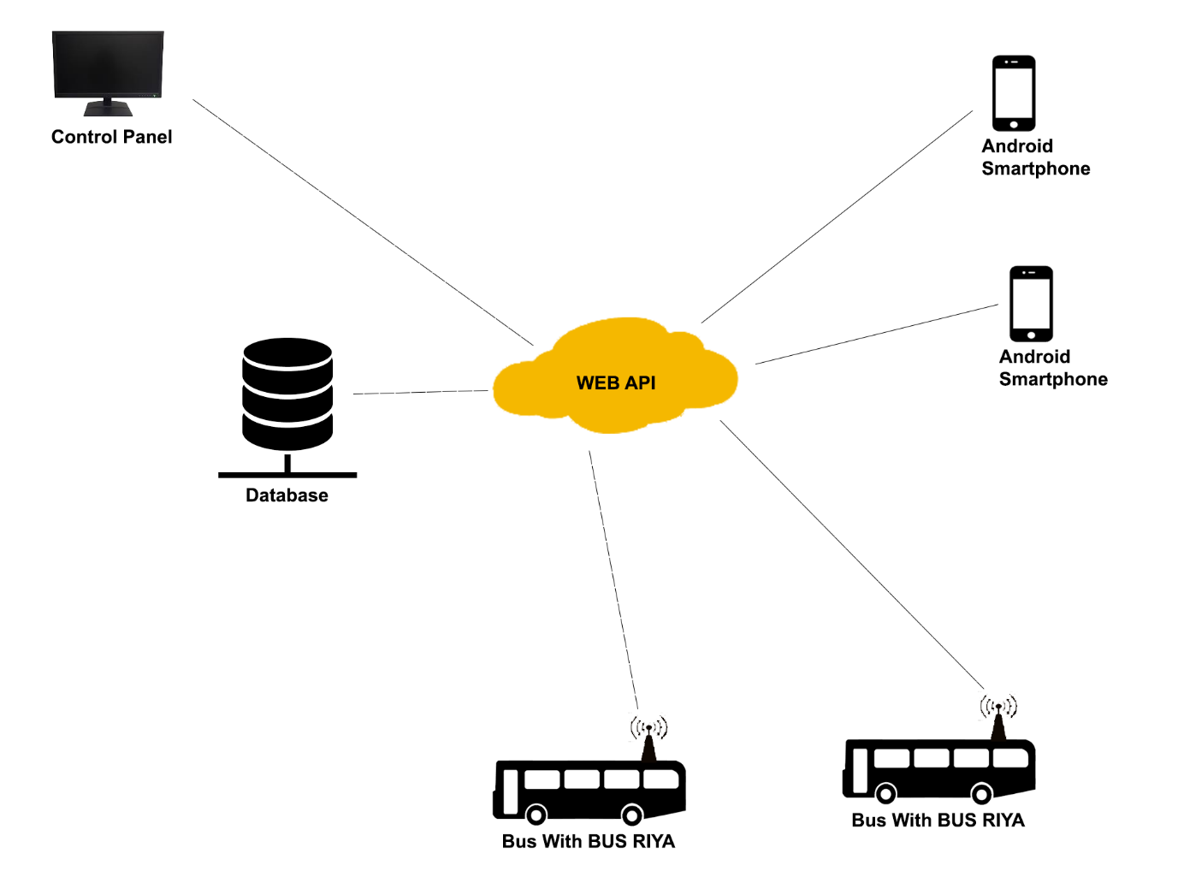

**WEB API**

* Middleware of the System.
* Controls the flow of information to each device and interface.

**Database**

* Central Storage of all information from buses and customers.

**Control Panel**

* Grants a god view of all buses equipped with BUS Riya
* Available only for the administration.
* Can Stop a Bus If faced with danger.

**BUS Riya Device**

* Transmit Bus GPS coordinates.
* Calculate Free Seat Capacity.
* Determine Bus Speed.

**Android Application**

* Account Creation
* Location of Nearest Buses
* Arrival Time of the Nearest Buses
* Current Free Seat Capacity of Buses
* Rate the experience on the bus.

# Software Requirements Specification

All components can act as independent units or work as a whole system when needed.

## Functional Requirements

The Needed Functionality of the Information System.

1. Monitor Travelling Speed of Buses.
2. Monitor Current Location of Buses.
3. Inform Passengers about Bus Location.
4. Inform Bus Driver If Maximum Waiting Time exceeded.
5. Inform Bus Driver If Maximum/Minimum Speed Limit is exceeded/Decreased.
6. Passengers can Rate the Travel Experience.
7. Check if Maximum Passenger Limit is exceeded.

## Non-Functional Requirements

The Additional Functionality of the Information System.

1. User Friendly GUI (Graphical User Interface)
2. Android App for Mobile.
3. Windows App for Desktop.
4. High Speed Communication between appliances.
5. Powerful changing encryption (Keys change every 30 minutes) that uses RSA encryption.
6. Easy configurable system (Hardware and software).
7. Obtain Comprehensive Reports.

# Technologies and Requirements

This project will be accomplished by combining electronics and software.

## Software Technologies

* C# – Development of the Desktop Application and Web Server
* Ionic/Android – Development of Mobile Application
* C/C++ – Development of the Micro-Controller ICs (Integrated Circuits)
* PHP – Development of API

### Other Technologies

* REST full web services
* REST Sharp
* WCF (Windows Communication Foundation)
* Azure App Services

### Third Party Software

* Ionic Creator
* Android Studio
* Visual Studio Enterprise
* Visual Studio Code
* Arduino
* Adobe Photoshop CC

## Hardware Technologies

* **SIM800C SMS Module**

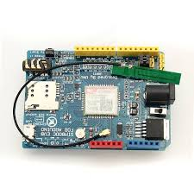

To Communicate with the server through mobile data. This module contains a SIM card that enables this feature.

* **NEO-6m GPS Module**

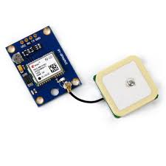

To get the current location of the BUS

* **Pressure Sensor**

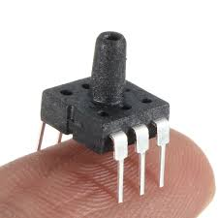

To Calculate the Seat Capacity.

* 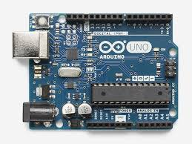**Arduino Uno**

This is the micro-controller which controls all the other electrical components.

# Assumptions

* All the functionality of the system can be achieved with an initial investment of minimum of Rs.2000/= and a Maximum of Rs.7000/=
* Unreasonable waiting time of buses can be eliminated.
* Passengers can get accurate location of buses on routes.
* Limit the maximum and minimum speed of a bus.

# Building Stages

**Stage 1**-

* Draw necessary UML Diagrams
* Design servers
* Develop database
* Test servers

**Stage 2**-

* Gather required sensors
* Develop arduino model
* Testing arduino model

**Stage 3**-

* Start Developing mobile app
* Testing mobile app

**Stage 4**-

* Start Developing desktop app
* Testing desktop app

**Stage 5**-

* Test final product

# Tentative Timeline

|  |  |  |  |
| --- | --- | --- | --- |
| Stage | February | March | April |
| 1 |  |  |  |
| 2 |  |  |  |
| 3 |  |  |  |
| 4 |  |  |  |
| 5 |  |  |  |